Financial Diligence Partners
The People

Larry Lee, senior partner at Financial Diligence Partners, began his insurance and financial services career in 1969, moving to California in 1977. A proud graduate of Iowa State University, he is also a graduate of the Chartered Life Underwriter (CLU) and Chartered Financial Consultant (ChFC) programs from the American College in Bryn Mawr, PA. Larry is an active member of the National Association of Insurance and Financial Advisors and former president of NAIFA California (2005/2006), a qualifying and life member of the Million Dollar Round Table, a member of the Society of Financial Service Professionals, and the South Orange County Estate planning council. He was the recipient of the NAIFA-California Distinguished Service Award in 2012 and the Will Farrell Award in 2014. Currently Larry serves on NAIFA’s Political Involvement Committee. Outside the office, Larry’s wife Jeanine shares him with the golf course, Ducks games, their three children and seven grandchildren.

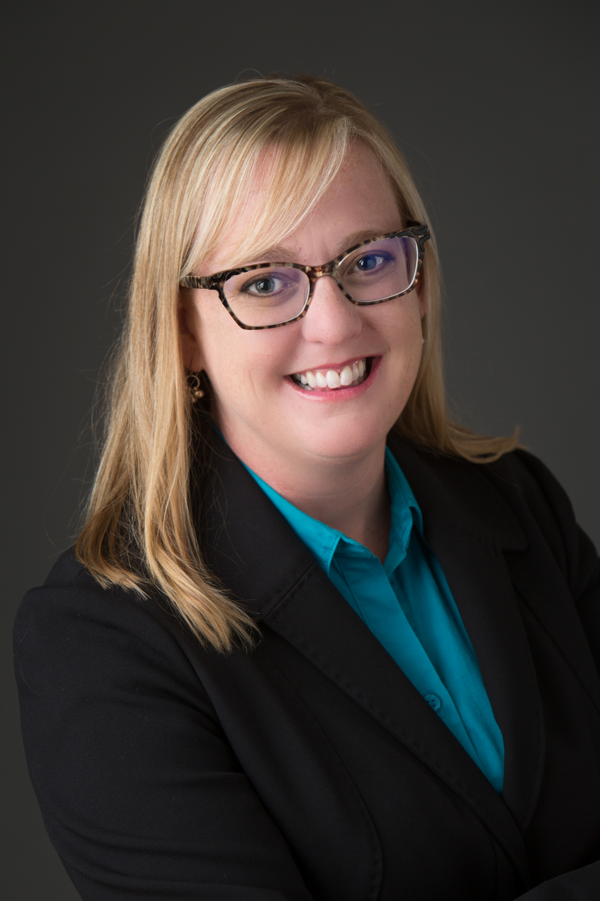
Carrie DeVanna joined Financial Diligence Partners in May of 2016 as a Customer Relations Specialist. Working closely with Larry, she takes care of customer and employee relations, facilitating client follow-through and directly addressing the needs of those on both sides of the FDP equation. Carrie has had an Insurance License for over 9 years. She also has managed various medical and insurance offices over the last 15 years and has a BS in Office Management. Carrie and her husband Brett live in San Clemente with their two sons, Blake and Mason. Carrie enjoys traveling and getting to spend time with her family and friends.

8841 Research Drive
Suite 100
Irvine, CA 92618

tel: 949.855.4337
fax: 949.855.4330
www.4fdp.com
Investments and advisory services offered through registered representatives of Lincoln Financial Securities, Member FINRA/SIPC, and a registered investment advisor. Insurance offered through LFS marketing & Insurance Sales Corporation.

